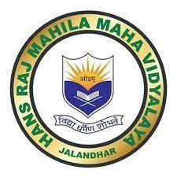
7.1.11
Institution Celebrates National and International days, events and festivals
ANY OTHER RELEVANT INFORMATION

ANNUAL REPORT
- HMV NEWS, Session 2023-24

https://drive.google.com/file/d/13Cx3zLCHl4FIzCzFLHRA5Y1fi3YzqI1L/view?usp=drivesdk

All activities of college are also shared on social media.

- HMV FACEBOOK PAGE: https://www.facebook.com/hmvofficial/

- HMV NEWS BLOGSPOT: http://hmvnews.blogspot.com/

